CABLE SAFE LIMITED
TELEPHONE: 01302 726264 e-mail: sales@cablesafe.co.uk
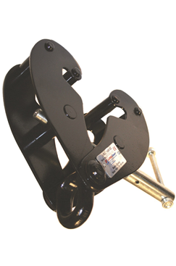
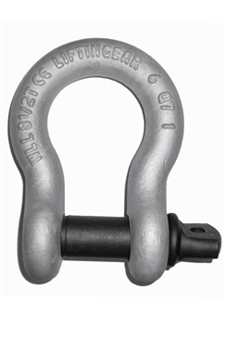
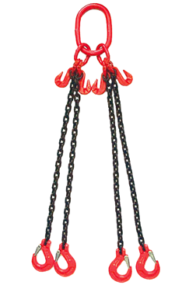

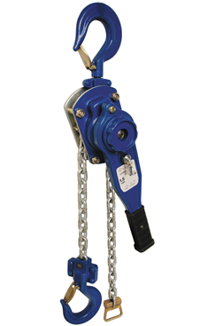
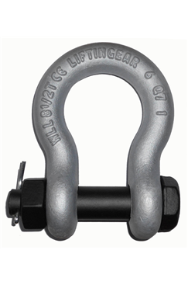

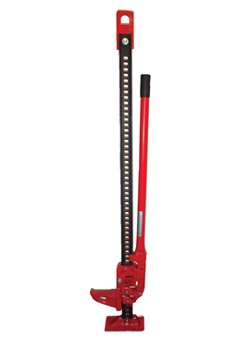
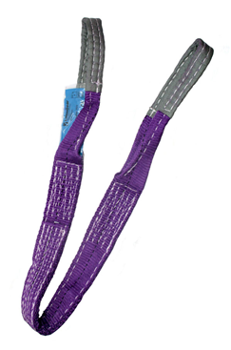

LIFTING PRODUCT
PRICE GUIDE
Chartered Institute of Environmental Health Professional Trainers
Registered office: The Lymes off old York Road, Hillcrest, Skellow, Doncaster, South Yorkshire DN6 8LN
Reg. No 3953535 E-mail: sales@cablesafe.co.uk www.cablesafe.co.uk
Tel: 01302 726264 Fax: 01302 722438

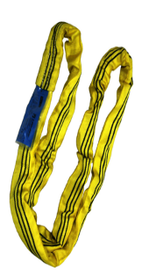
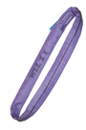
ROUND SLINGS

SWL | LENGTH EWL | LENGTH  CIRC | COLOUR | PRICE
1 tonne | 0.5mtr | 1mtr | Purple | £1.86
1 tonne | 1mtr | 2mtr | Purple | £2.19
1 tonne | 1.5mtr | 3mtr | Purple | £2.89
1 tonne | 2mtr | 4mtr | Purple | £3.45
1 tonne | 2.5mtr | 5mtr | Purple | £4.77
1 tonne | 3mtr | 6mtr | Purple | £5.25
1 tonne | 4mtr | 8mtr | Purple | £8.00
1 tonne | 5mtr | 10mtr | Purple | £9.33
1 tonne | 6mtr | 12mtr | Purple | £10.74
2 tonne | 0.5mtr | 1mtr | Green | £2.25
2 tonne | 1mtr | 2mtr | Green | £3.15
2 tonne | 1.5mtr | 3mtr | Green | £3.95
2 tonne | 2mtr | 4mtr | Green | £5.48
2 tonne | 2.5mtr | 5mtr | Green | £6.34
2 tonne | 3mtr | 6mtr | Green | £7.61
2 tonne | 4mtr | 8mtr | Green | £10.28
2 tonne | 5mtr | 10mtr | Green | £12.64
2 tonne | 6mtr | 12mtr | Green | £14.65
3 tonne | 0.5mtr | 1mtr | Yellow | £3.19
3 tonne | 1mtr | 2mtr | Yellow | £3.76
3 tonne | 1.5mtr | 3mtr | Yellow | £5.48
3 tonne | 2mtr | 4mtr | Yellow | £6.84
3 tonne | 2.5mtr | 5mtr | Yellow | £8.57
3 tonne | 3mtr | 6mtr | Yellow | £10.06
3 tonne | 4mtr | 8mtr | Yellow | £13.50
3 tonne | 5mtr | 10mtr | Yellow | £16.94
3 tonne | 6mtr | 12mtr | Yellow | £19.80
4 tonne | 1mtr | 2mtr | Grey | £4.86
4 tonne | 1.5mtr | 3mtr | Grey | £6.84
4 tonne | 2mtr | 4mtr | Grey | £9.13
4 tonne | 2.5mtr | 5mtr | Grey | £11.42
4 tonne | 3mtr | 6mtr | Grey | £14.27
4 tonne | 4mtr | 8mtr | Grey | £20.59
4 tonne | 5mtr | 10mtr | Grey | £25.98
4 tonne | 6mtr | 12mtr | Grey | £29.94

All price excludes VAT & Carriage

ROUND SLINGS

SWL | LENGTH EWL | LENGTH  CIRC | COLOUR | PRICE
5 tonne | 1mtr | 2mtr | Red | £5.94
5 tonne | 1.5mtr | 3mtr | Red | £8.57
5 tonne | 2mtr | 4mtr | Red | £11.66
5 tonne | 2.5mtr | 5mtr | Red | £16.01
5 tonne | 3mtr | 6mtr | Red | £18.08
5 tonne | 4mtr | 8mtr | Red | £20.66
5 tonne | 5mtr | 10mtr | Red | £25.53
5 tonne | 6mtr | 12mtr | Red | £33.09
6 tonne | 1.5mtr | 3mtr | Brown | £12.20
6 tonne | 2mtr | 4mtr | Brown | £18.84
6 tonne | 3mtr | 6mtr | Brown | £26.31
6 tonne | 4mtr | 8mtr | Brown | £32.40
6 tonne | 5mtr | 10mtr | Brown | £39.44
6 tonne | 6mtr | 12mtr | Brown | £48.08
8 tonne | 2mtr | 4mtr | Blue | £21.06
8 tonne | 3mtr | 6mtr | Blue | £31.59
8 tonne | 4mtr | 8mtr | Blue | £41.97
8 tonne | 5mtr | 10mtr | Blue | £53.21
8 tonne | 6mtr | 12mtr | Blue | £63.44
10 tonne | 3mtr | 6mtr | Orange | £51.51
10 tonne | 4mtr | 8mtr | Orange | £67.33
10 tonne | 6mtr | 12mtr | Orange | £100.77
10 tonne | 8mtr | 16mtr | Orange | £137.15
10 tonne | 10mtr | 20mtr | Orange | £160.23
12 tonne | 3mtr | 6mtr | Orange | £49.23
12 tonne | 4mtr | 8mtr | Orange | £72.89
12 tonne | 6mtr | 12mtr | Orange | £110.53
12 tonne | 8mtr | 16mtr | Orange | £147.39
12 tonne | 10mtr | 20mtr | Orange | £184.62

LARGER SLINGS AVAILABLE ON REQUEST
All price excludes VAT & Carriage
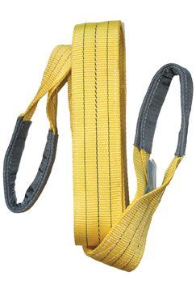
FLAT WEBBING SLINGS

SWL | LENGTH EWL | DESCRIPTION | COLOUR | PRICE
1 tonne | 1mtr | Polyester Duplex | Purple | £1.98
1 tonne | 2mtr | Polyester Duplex | Purple | £3.06
1 tonne | 3mtr | Polyester Duplex | Purple | £4.13
1 tonne | 4mtr | Polyester Duplex | Purple | £5.25
1 tonne | 5mtr | Polyester Duplex | Purple | £6.16
1 tonne | 6mtr | Polyester Duplex | Purple | £7.26
1 tonne | 8mtr | Polyester Duplex | Purple | £9.28
1 tonne | 10mtr | Polyester Duplex | Purple | £11.14
2 tonne | 1mtr | Polyester Duplex | Green | £3.02
2 tonne | 2mtr | Polyester Duplex | Green | £5.30
2 tonne | 3mtr | Polyester Duplex | Green | £7.30
2 tonne | 4mtr | Polyester Duplex | Green | £8.95
2 tonne | 5mtr | Polyester Duplex | Green | £12.32
2 tonne | 6mtr | Polyester Duplex | Green | £13.15
2 tonne | 8mtr | Polyester Duplex | Green | £16.32
2 tonne | 10mtr | Polyester Duplex | Green | £20.04
3 tonne | 1mtr | Polyester Duplex | Yellow | £4.85
3 tonne | 2mtr | Polyester Duplex | Yellow | £8.09
3 tonne | 3mtr | Polyester Duplex | Yellow | £11.19
3 tonne | 4mtr | Polyester Duplex | Yellow | £13.92
3 tonne | 5mtr | Polyester Duplex | Yellow | £17.15
3 tonne | 6mtr | Polyester Duplex | Yellow | £19.81
3 tonne | 8mtr | Polyester Duplex | Yellow | £24.55
3 tonne | 10mtr | Polyester Duplex | Yellow | £33.08
3 tonne | 12mtr | Polyester Duplex | Yellow | £37.35
4 tonne | 2mtr | Polyester Duplex | Grey | £10.11
4 tonne | 3mtr | Polyester Duplex | Grey | £14.37
4 tonne | 4mtr | Polyester Duplex | Grey | £18.96
4 tonne | 5mtr | Polyester Duplex | Grey | £22.02
4 tonne | 6mtr | Polyester Duplex | Grey | £25.49
4 tonne | 8mtr | Polyester Duplex | Grey | £37.35
4 tonne | 10mtr | Polyester Duplex | Grey | £40.50

All price excludes VAT & Carriage
FLAT WEBBING SLINGS

SWL | LENGTH EWL | DESCRIPTION | COLOUR | PRICE
5 tonne | 2mtr | Polyester Duplex | Red | £13.38
5 tonne | 3mtr | Polyester Duplex | Red | £18.05
5 tonne | 4mtr | Polyester Duplex | Red | £23.40
5 tonne | 5mtr | Polyester Duplex | Red | £28.38
5 tonne | 6mtr | Polyester Duplex | Red | £33.03
5 tonne | 8mtr | Polyester Duplex | Red | £42.28
5 tonne | 10mtr | Polyester Duplex | Red | £53.85
5 tonne | 12mtr | Polyester Duplex | Red | £63.06
6 tonne | 2mtr | Polyester Duplex | Brown | £18.88
6 tonne | 3mtr | Polyester Duplex | Brown | £26.16
6 tonne | 4mtr | Polyester Duplex | Brown | £33.09
6 tonne | 5mtr | Polyester Duplex | Brown | £40.54
6 tonne | 6mtr | Polyester Duplex | Brown | £47.89
6 tonne | 8mtr | Polyester Duplex | Brown | £62.18
6 tonne | 10mtr | Polyester Duplex | Brown | £74.16
6 tonne | 12mtr | Polyester Duplex | Brown | £81.92
8 tonne | 2mtr | Polyester Duplex | Blue | £28.61
8 tonne | 3mtr | Polyester Duplex | Blue | £39.01
8 tonne | 4mtr | Polyester Duplex | Blue | £45.96
8 tonne | 5mtr | Polyester Duplex | Blue | £53.46
8 tonne | 6mtr | Polyester Duplex | Blue | £62.12
8 tonne | 8mtr | Polyester Duplex | Blue | £78.63
8 tonne | 10mtr | Polyester Duplex | Blue | £91.42
10 tonne | 3mtr | Polyester Duplex | Orange | £50.95
10 tonne | 4mtr | Polyester Duplex | Orange | £59.46
10 tonne | 6mtr | Polyester Duplex | Orange | £77.39
10 tonne | 8mtr | Polyester Duplex | Orange | £100.21
10 tonne | 10mtr | Polyester Duplex | Orange | £120.79
10 tonne | 12mtr | Polyester Duplex | Orange | £143.48
12 tonne | 4mtr | Polyester Duplex | Orange | £66.87
12 tonne | 6mtr | Polyester Duplex | Orange | £89.82
12 tonne | 8mtr | Polyester Duplex | Orange | £119.49
12 tonne | 10mtr | Polyester Duplex | Orange | £139.64
12 tonne | 12mtr | Polyester Duplex | Orange | £167.29

LARGER SLINGS AVAILABLE ON REQUEST
All price excludes VAT & Carriage
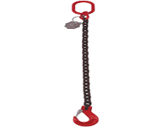
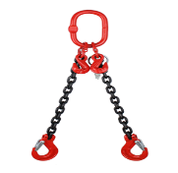
CHAIN SLINGS

SIZE | GRADE | DESCRIPTION | EWL | SWL | Price
7mm | 80 | Single leg chain sling fitted with sling hook | 1mtr | 1.5t | £24.46
7mm | 80 | Single leg chain sling fitted with sling hook & shortener | 2mtr | 1.5t | £29.52
7mm | 80 | Single leg chain sling fitted with sling hook & shortener | 3mtr | 1.5t | £37.54
7mm | 80 | Single leg chain sling fitted with sling hook & shortener | 4mtr | 1.5t | £41.60
7mm | 80 | Single leg chain sling fitted with sling hook & shortener | 5mtr | 1.5t | £45.81
7mm | 80 | Single leg chain sling fitted with sling hook & shortener | 6mtr | 1.5t | £48.95
8mm | 80 | Single leg chain sling fitted with sling hook | 1mtr | 2t | £25.68
8mm | 80 | Single leg chain sling fitted with sling hook & shortener | 2mtr | 2t | £30.85
8mm | 80 | Single leg chain sling fitted with sling hook & shortener | 3mtr | 2t | £39.15
8mm | 80 | Single leg chain sling fitted with sling hook & shortener | 4mtr | 2t | £43.78
8mm | 80 | Single leg chain sling fitted with sling hook & shortener | 5mtr | 2t | £51.39
8mm | 80 | Single leg chain sling fitted with sling hook & shortener | 6mtr | 2t | £62.14
10mm | 80 | Single leg chain sling fitted with sling hook | 1mtr | 3.15t | £36.22
10mm | 80 | Single leg chain sling fitted with sling hook & shortener | 2mtr | 3.15t | £44.04
10mm | 80 | Single leg chain sling fitted with sling hook & shortener | 3mtr | 3.15t | £56.73
10mm | 80 | Single leg chain sling fitted with sling hook & shortener | 4mtr | 3.15t | £62.25
10mm | 80 | Single leg chain sling fitted with sling hook & shortener | 6mtr | 3.15t | £76.36
13mm | 80 | Single leg chain sling fitted with sling hook | 1mtr | 5.3t | £61.19
13mm | 80 | Single leg chain sling fitted with sling hook & shortener | 2mtr | 5.3t | £72.45
13mm | 80 | Single leg chain sling fitted with sling hook & shortener | 3mtr | 5.3t | £95.34
13mm | 80 | Single leg chain sling fitted with sling hook & shortener | 4mtr | 5.3t | £107.71
13mm | 80 | Single leg chain sling fitted with sling hook & shortener | 6mtr | 3.3t | £127.22
16mm | 80 | Single leg chain sling fitted with sling hook | 1mtr | 8t | £93.02
16mm | 80 | Single leg chain sling fitted with sling hook & shortener | 2mtr | 8t | £112.60
16mm | 80 | Single leg chain sling fitted with sling hook & shortener | 3mtr | 8t | £146.63
16mm | 80 | Single leg chain sling fitted with sling hook & shortener | 4mtr | 8t | £164.51
16mm | 80 | Single leg chain sling fitted with sling hook & shortener | 6mtr | 8t | £195.84

Other lengths are available on request
Safety Hooks, ‘C’ Hooks and other fittings are also available on request
All price excludes VAT & Carriage
CHAIN SLINGS

SIZE | GRADE | DESCRIPTION | EWL | SWL | Price
6mm | 100 | Single leg chain sling fitted with sling hook | 1mtr | 1.4t | £27.86
6mm | 100 | Single leg chain sling fitted with sling hook & shortener | 2mtr | 1.4t | £32.71
6mm | 100 | Single leg chain sling fitted with sling hook & shortener | 3mtr | 1.4t | £41.74
6mm | 100 | Single leg chain sling fitted with sling hook & shortener | 4mtr | 1.4t | £47.04
6mm | 100 | Single leg chain sling fitted with sling hook & shortener | 5mtr | 1.4t | £51.62
6mm | 100 | Single leg chain sling fitted with sling hook & shortener | 6mtr | 1.4t | £55.26
8mm | 100 | Single leg chain sling fitted with sling hook | 1mtr | 2.5t | £29.26
8mm | 100 | Single leg chain sling fitted with sling hook & shortener | 2mtr | 2.5t | £35.18
8mm | 100 | Single leg chain sling fitted with sling hook & shortener | 3mtr | 2.5t | £44.62
8mm | 100 | Single leg chain sling fitted with sling hook & shortener | 4mtr | 2.5t | £50.53
8mm | 100 | Single leg chain sling fitted with sling hook & shortener | 5mtr | 2.5t | £56.46
8mm | 100 | Single leg chain sling fitted with sling hook & shortener | 6mtr | 2.5t | £62.39
10mm | 100 | Single leg chain sling fitted with sling hook | 1mtr | 4t | £40.03
10mm | 100 | Single leg chain sling fitted with sling hook & shortener | 2mtr | 4t | £48.23
10mm | 100 | Single leg chain sling fitted with sling hook & shortener | 3mtr | 4t | £62.98
10mm | 100 | Single leg chain sling fitted with sling hook & shortener | 4mtr | 4t | £71.19
10mm | 100 | Single leg chain sling fitted with sling hook & shortener | 6mtr | 4t | £87.60
13mm | 100 | Single leg chain sling fitted with sling hook | 1mtr | 6.7t | £88.41
13mm | 100 | Single leg chain sling fitted with sling hook & shortener | 2mtr | 6.7t | £100.17
13mm | 100 | Single leg chain sling fitted with sling hook & shortener | 3mtr | 6.7t | £121.72
13mm | 100 | Single leg chain sling fitted with sling hook & shortener | 4mtr | 6.7t | £135.33
13mm | 100 | Single leg chain sling fitted with sling hook & shortener | 6mtr | 6.7t | £161.32

Other lengths are available on request
Safety Hooks, ‘C’ Hooks and other fittings are also available on request
All price excludes VAT & Carriage
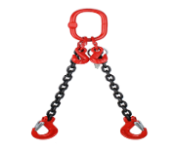
CHAIN SLINGS

SIZE | GRADE | DESCRIPTION | EWL | SWL | Price
7mm | 80 | Two leg chain sling fitted with sling hook & shortener | 2mtr | 2.1t @ 0-45 | £63.65
7mm | 80 | Two leg chain sling fitted with sling hook & shortener | 3mtr | 2.1t @ 0-45 | £73.44
7mm | 80 | Two leg chain sling fitted with sling hook & shortener | 4mtr | 2.1t @ 0-45 | £82.37
7mm | 80 | Two leg chain sling fitted with sling hook & shortener | 5mtr | 2.1t @ 0-45 | £88.18
7mm | 80 | Two leg chain sling fitted with sling hook & shortener | 6mtr | 2.1t @ 0-45 | £97.92
10mm | 80 | Two leg chain sling fitted with sling hook & shortener | 2mtr | 4.25t @ 0-45 | £97.92
10mm | 80 | Two leg chain sling fitted with sling hook & shortener | 3mtr | 4.25t @ 0-45 | £107.72
10mm | 80 | Two leg chain sling fitted with sling hook & shortener | 4mtr | 4.25t @ 0-45 | £122.66
10mm | 80 | two leg chain sling fitted with sling hook & shortener | 5mtr | 4.25t @ 0-45 | £133.94
10mm | 80 | two leg chain sling fitted with sling hook & shortener | 6mtr | 4.25t @ 0-45 | £146.89
13mm | 80 | Two leg chain sling fitted with sling hook & shortener | 2mtr | 7.5t @ 0-45 | £156.68
13mm | 80 | Two leg chain sling fitted with sling hook & shortener | 3mtr | 7.5t @ 0-45 | £176.26
13mm | 80 | Two leg chain sling fitted with sling hook & shortener | 4mtr | 7.5t @ 0-45 | £196.12
13mm | 80 | Two leg chain sling fitted with sling hook & shortener | 5mtr | 7.5t @ 0-45 | £220.34
13mm | 80 | Two leg chain sling fitted with sling hook & shortener | 6mtr | 7.5t @ 0-45 | £244.33
16mm | 80 | Two leg chain sling fitted with sling hook & shortener | 2mtr | 11.2t @ 0-45 | £244.83
16mm | 80 | Two leg chain sling fitted with sling hook & shortener | 3mtr | 11.2t @ 0-45 | £284.00
16mm | 80 | Two leg chain sling fitted with sling hook & shortener | 4mtr | 11.2t @ 0-45 | £323.17
16mm | 80 | Two leg chain sling fitted with sling hook & shortener | 5mtr | 11.2t @ 0-45 | £342.59
16mm | 80 | Two leg chain sling fitted with sling hook & shortener | 6mtr | 11.2t @ 0-45 | £329.72

Other lengths are available on request
Safety Hooks, ‘C’ Hooks and other fittings are also available on request

All price excludes VAT & Carriage
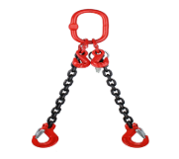
CHAIN SLINGS

SIZE | GRADE | DESCRIPTION | EWL | SWL | Price
6mm | 100 | Two leg chain sling fitted with sling hook & shortener | 2mtr | 2t @ 0-45 | £62.25
6mm | 100 | Two leg chain sling fitted with sling hook & shortener | 3mtr | 2t @ 0-45 | £72.35
6mm | 100 | Two leg chain sling fitted with sling hook & shortener | 4mtr | 2t @ 0-45 | £77.47
6mm | 100 | Two leg chain sling fitted with sling hook & shortener | 5mtr | 2t @ 0-45 | £92.60
6mm | 100 | Two leg chain sling fitted with sling hook & shortener | 6mtr | 2t @ 0-45 | £102.81
8mm | 100 | Two leg chain sling fitted with sling hook & shortener | 2mtr | 3.5t @ 0-45 | £74.42
8mm | 100 | Two leg chain sling fitted with sling hook & shortener | 3mtr | 3.5t @ 0-45 | £84.47
8mm | 100 | Two leg chain sling fitted with sling hook & shortener | 4mtr | 3.5t @ 0-45 | £97.87
8mm | 100 | Two leg chain sling fitted with sling hook & shortener | 5mtr | 3.5t @ 0-45 | £104.74
8mm | 100 | Two leg chain sling fitted with sling hook & shortener | 6mtr | 3.5t @ 0-45 | £116.18
10mm | 100 | Two leg chain sling fitted with sling hook & shortener | 2mtr | 5.6t @ 0-45 | £105.15
10mm | 100 | Two leg chain sling fitted with sling hook & shortener | 3mtr | 5.6t @ 0-45 | £117.10
10mm | 100 | Two leg chain sling fitted with sling hook & shortener | 4mtr | 5.6t @ 0-45 | £130.57
10mm | 100 | two leg chain sling fitted with sling hook & shortener | 5mtr | 5.6t @ 0-45 | £146.82
10mm | 100 | two leg chain sling fitted with sling hook & shortener | 6mtr | 5.6t @ 0-45 | £163.20
13mm | 100 | Two leg chain sling fitted with sling hook & shortener | 2mtr | 9.4t @ 0-45 | £167.14
13mm | 100 | Two leg chain sling fitted with sling hook & shortener | 3mtr | 9.4t @ 0-45 | £191.20
13mm | 100 | Two leg chain sling fitted with sling hook & shortener | 4mtr | 9.4t @ 0-45 | £211.36
13mm | 100 | Two leg chain sling fitted with sling hook & shortener | 5mtr | 9.4t @ 0-45 | £238.58
13mm | 100 | Two leg chain sling fitted with sling hook & shortener | 6mtr | 9.4t @ 0-45 | £265.80

Other lengths are available on request
Safety Hooks, ‘C’ Hooks and other fittings are also available on request
All price excludes VAT & Carriage
CHAIN SLINGS

SIZE | GRADE | DESCRIPTION | EWL | SWL | Price
7mm | 80 | Four leg chain sling fitted with sling hook & shortener | 2mtr | 3.15t @ 0-45 | £133.63
7mm | 80 | Four leg chain sling fitted with sling hook & shortener | 3mtr | 3.15t @ 0-45 | £143.59
7mm | 80 | Four leg chain sling fitted with sling hook & shortener | 4mtr | 3.15t @ 0-45 | £161.02
7mm | 80 | Four leg chain sling fitted with sling hook & shortener | 5mtr | 3.15t @ 0-45 | £176.26
7mm | 80 | Four leg chain sling fitted with sling hook & shortener | 6mtr | 3.15t @ 0-45 | £190.90
8mm | 80 | Four leg chain sling fitted with sling hook & shortener | 2mtr | 4.25t @ 0-45 | £141.99
8mm | 80 | Four leg chain sling fitted with sling hook & shortener | 3mtr | 4.25t @ 0-45 | £156.68
8mm | 80 | Four leg chain sling fitted with sling hook & shortener | 4mtr | 4.25t @ 0-45 | £176.26
8mm | 80 | Four leg chain sling fitted with sling hook & shortener | 5mtr | 4.25t @ 0-45 | £205.64
8mm | 80 | Four leg chain sling fitted with sling hook & shortener | 6mtr | 4.25t @ 0-45 | £230.14
10mm | 80 | Four leg chain sling fitted with sling hook & shortener | 2mtr | 6.7t @ 0-45 | £179.70
10mm | 80 | Four leg chain sling fitted with sling hook & shortener | 3mtr | 6.7t @ 0-45 | £205.41
10mm | 80 | Four leg chain sling fitted with sling hook & shortener | 4mtr | 6.7t @ 0-45 | £228.95
10mm | 80 | Four leg chain sling fitted with sling hook & shortener | 6mtr | 6.7t @ 0-45 | £286.05
13mm | 80 | Four leg chain sling fitted with sling hook & shortener | 2mtr | 11.2t @ 0-45 | £311.65
13mm | 80 | Four leg chain sling fitted with sling hook & shortener | 3mtr | 11.2t @ 0-45 | £367.71
13mm | 80 | Four leg chain sling fitted with sling hook & shortener | 4mtr | 11.2t @ 0-45 | £423.73
13mm | 80 | Four leg chain sling fitted with sling hook & shortener | 6mtr | 11.2t @ 0-45 | £537.98
16mm | 80 | Four leg chain sling fitted with sling hook & shortener | 2mtr | 17t @ 0-45 | £503.45
16mm | 80 | Four leg chain sling fitted with sling hook & shortener | 3mtr | 17t @ 0-45 | £588.67
16mm | 80 | Four leg chain sling fitted with sling hook & shortener | 4mtr | 17t @ 0-45 | £673.89
16mm | 80 | Four leg chain sling fitted with sling hook & shortener | 6mtr | 17t @ 0-45 | £844.74

Other lengths are available on request
Safety Hooks, ‘C’ Hooks and other fittings are also available on request
All price excludes VAT & Carriage

CHAIN SLINGS

SIZE | GRADE | DESCRIPTION | EWL | SWL | Price
6mm | 100 | Four leg chain sling fitted with sling hook & shortener | 2mtr | 2.9t @ 0-45 | £119.49
6mm | 100 | Four leg chain sling fitted with sling hook & shortener | 3mtr | 2.9t @ 0-45 | £140.09
6mm | 100 | Four leg chain sling fitted with sling hook & shortener | 4mtr | 2.9t @ 0-45 | £159.26
6mm | 100 | Four leg chain sling fitted with sling hook & shortener | 5mtr | 2.9t @ 0-45 | £179.09
6mm | 100 | Four leg chain sling fitted with sling hook & shortener | 6mtr | 2.9t @ 0-45 | £199.00
8mm | 100 | Four leg chain sling fitted with sling hook & shortener | 2mtr | 5.3t @ 0-45 | £151.76
8mm | 100 | Four leg chain sling fitted with sling hook & shortener | 3mtr | 5.3t @ 0-45 | £170.61
8mm | 100 | Four leg chain sling fitted with sling hook & shortener | 4mtr | 5.3t @ 0-45 | £188.70
8mm | 100 | Four leg chain sling fitted with sling hook & shortener | 5mtr | 5.3t @ 0-45 | £220.92
8mm | 100 | Four leg chain sling fitted with sling hook & shortener | 6mtr | 5.3t @ 0-45 | £245.87
10mm | 100 | Four leg chain sling fitted with sling hook & shortener | 2mtr | 8.4t @ 0-45 | £213.10
10mm | 100 | Four leg chain sling fitted with sling hook & shortener | 3mtr | 8.4t @ 0-45 | £238.98
10mm | 100 | Four leg chain sling fitted with sling hook & shortener | 4mtr | 8.4t @ 0-45 | £295.33
10mm | 100 | Four leg chain sling fitted with sling hook & shortener | 6mtr | 8.4t @ 0-45 | £333.46
13mm | 100 | Four leg chain sling fitted with sling hook & shortener | 2mtr | 14.1t @ 0-45 | £346.26
13mm | 100 | Four leg chain sling fitted with sling hook & shortener | 3mtr | 14.1t @ 0-45 | £400.69
13mm | 100 | Four leg chain sling fitted with sling hook & shortener | 4mtr | 14.1t @ 0-45 | £455.13
13mm | 100 | Four leg chain sling fitted with sling hook & shortener | 6mtr | 14.1t @ 0-45 | £563.98

Other lengths are available on request
Safety Hooks, ‘C’ Hooks and other fittings are also available on request
All price excludes VAT & Carriage
WIRE ROPE SLINGS
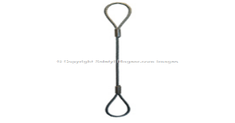
SIZE Diameter | DESCRIPTION | EWL | SWL | Price
6mm | Galvanised Wire Rope Sling C/W Soft Eyes Each End | 1mtr | 400Kgs | £4.86
6mm | Galvanised Wire Rope Sling C/W Soft Eyes Each End | 2mtr | 400Kgs | £6.29
6mm | Galvanised Wire Rope Sling C/W Soft Eyes Each End | 3mtr | 400Kgs | £7.73
6mm | Galvanised Wire Rope Sling C/W Soft Eyes Each End | 4mtr | 400Kgs | £9.14
6mm | Galvanised Wire Rope Sling C/W Soft Eyes Each End | 5mtr | 400Kgs | £10.59
6mm | Galvanised Wire Rope Sling C/W Soft Eyes Each End | 6mtr | 400Kgs | £12.34
8mm | Galvanised Wire Rope Sling C/W Soft Eyes Each End | 1mtr | 762Kgs | £5.30
8mm | Galvanised Wire Rope Sling C/W Soft Eyes Each End | 2mtr | 762Kgs | £6.81
8mm | Galvanised Wire Rope Sling C/W Soft Eyes Each End | 3mtr | 762Kgs | £8.31
8mm | Galvanised Wire Rope Sling C/W Soft Eyes Each End | 4mtr | 762Kgs | £9.83
8mm | Galvanised Wire Rope Sling C/W Soft Eyes Each End | 5mtr | 762Kgs | £11.34
8mm | Galvanised Wire Rope Sling C/W Soft Eyes Each End | 6mtr | 762Kgs | £12.86
10mm | Galvanised Wire Rope Sling C/W Soft Eyes Each End | 1mtr | 1000Kgs | £7.59
10mm | Galvanised Wire Rope Sling C/W Soft Eyes Each End | 2mtr | 1000Kgs | £9.10
10mm | Galvanised Wire Rope Sling C/W Soft Eyes Each End | 3mtr | 1000Kgs | £10.60
10mm | Galvanised Wire Rope Sling C/W Soft Eyes Each End | 4mtr | 1000Kgs | £12.12
10mm | Galvanised Wire Rope Sling C/W Soft Eyes Each End | 5mtr | 1000Kgs | £13.63
10mm | Galvanised Wire Rope Sling C/W Soft Eyes Each End | 6mtr | 1000Kgs | £15.15
13mm | Galvanised Wire Rope Sling C/W Soft Eyes Each End | 1mtr | 2000Kgs | £10.03
13mm | Galvanised Wire Rope Sling C/W Soft Eyes Each End | 2mtr | 2000Kgs | £12.42
13mm | Galvanised Wire Rope Sling C/W Soft Eyes Each End | 3mtr | 2000Kgs | £14.72
13mm | Galvanised Wire Rope Sling C/W Soft Eyes Each End | 4mtr | 2000Kgs | £17.07
13mm | Galvanised Wire Rope Sling C/W Soft Eyes Each End | 5mtr | 2000Kgs | £19.41
13mm | Galvanised Wire Rope Sling C/W Soft Eyes Each End | 6mtr | 2000Kgs | £21.73
16mm | Galvanised Wire Rope Sling C/W Soft Eyes Each End | 1mtr | 3000Kgs | £12.57
16mm | Galvanised Wire Rope Sling C/W Soft Eyes Each End | 2mtr | 3000Kgs | £16.42
16mm | Galvanised Wire Rope Sling C/W Soft Eyes Each End | 3mtr | 3000Kgs | £20.47
16mm | Galvanised Wire Rope Sling C/W Soft Eyes Each End | 4mtr | 3000Kgs | £24.52
16mm | Galvanised Wire Rope Sling C/W Soft Eyes Each End | 5mtr | 3000Kgs | £28.58
16mm | Galvanised Wire Rope Sling C/W Soft Eyes Each End | 6mtr | 3000Kgs | £32.64
22mm | Galvanised Wire Rope Sling C/W Soft Eyes Each End | 2mtr | 5700Kgs | £28.40
22mm | Galvanised Wire Rope Sling C/W Soft Eyes Each End | 3mtr | 5700Kgs | £35.04
22mm | Galvanised Wire Rope Sling C/W Soft Eyes Each End | 4mtr | 3570Kgs | £41.80
22mm | Galvanised Wire Rope Sling C/W Soft Eyes Each End | 5mtr | 5700Kgs | £48.50
22mm | Galvanised Wire Rope Sling C/W Soft Eyes Each End | 6mtr | 5700Kgs | £55.20
Other lengths are available on request
All price excludes VAT & Carriage
DEE SHACKLES STEEL (Self Coloured)
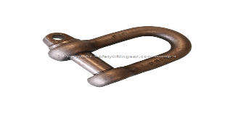
DESCRIPTION | Pin Size | Internal Length B/B | Internal width between Jaws | SWL | Price
Steel D Shackle Type A (screw pin) | ½ “ | 1½ “ | ¾ “ | 0.5t | £1.40
Steel D Shackle Type A (screw pin) | 5/8” | 2. 1/8 | 1.1/8 | 0.75t | £1.90
Steel D Shackle Type A (screw pin) | 5/8” | 1.7/8” | 7/8” | 1t | £2.26
Steel D Shackle Type A (screw pin) | ¾ “ | 2.12” | 1.1/4 | 1.5t | £3.07
Steel D Shackle Type A (screw pin) | 7/8” | 2.7/8” | 1.1/2” | 2t | £4.05
Steel D Shackle Type A (screw pin) | 1” | 3.1/4” | 1.3/4” | 3t | £5.13
Steel D Shackle Type A (screw pin) | 1.1/8” | 3.3/3” | 2” | 3.75t | £9.03
Steel D Shackle Type A (screw pin) | 1.1/4” | 4.1/8” | 2.1/8 | 5t | £10.28
Steel D Shackle Type A (screw pin) | 1.3/8” | 4.1/2” | 2.3/8” | 6t | £15.72
Steel D Shackle Type A (screw pin) | 1.1/2” | 5” | 2.5/8” | 7t | £20.75
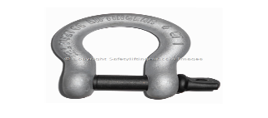
BOW SHACKLES STEEL (Galvanised)

DESCRIPTION | Pin Size | Internal Length B/B | Internal width between Jaws | SWL | Price
Alloy Bow Shackle Type A (screw pin) | 16mm | 47.3mm | 20.6mm | 2t | £2.28
Alloy Bow Shackle Type A (screw pin) | 19.8mm | 60.5mm | 27mm | 3.25t | £3.33
Alloy Bow Shackle Type A (screw pin) | 22mm | 71.5mm | 32mm | 4.75t | £4.56
Alloy Bow Shackle Type A (screw pin) | 27mm | 84mm | 36.6mm | 6.5t | £5.60
Alloy Bow Shackle Type A (screw pin) | 28mm | 95mm | 43mm | 8.5t | £9.13
Alloy Bow Shackle Type A (screw pin) | 33mm | 108mm | 46mm | 9.5t | £12.52
Alloy Bow Shackle Type A (screw pin) | 33mm | 119mm | 46mm | 12t | £17.05
Alloy Bow Shackle Type A (screw pin) | 38mm | 133mm | 57mm | 13.5t | £21.73
Alloy Bow Shackle Type A (screw pin) | 42mm | 146mm | 60mm | 17t | £28.61
Alloy Bow Shackle Type A (screw pin) | 50mm | 178mm | 74mm | 25t | £45.79
Alloy Bow Shackle Type A (screw pin) | 57mm | 197mm | 83mm | 35t | £68.69
Alloy Bow Shackle Type A (screw pin) | 70mm | 254mm | 105mm | 55t | £147.64
Alloy Bow Shackle Type A (screw pin) | 83mm | 329mm | 127mm | 85t | £280.33

All price excludes VAT & Carriage

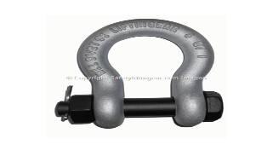
BOW SHACKLES STEEL (Galvanised)

DESCRIPTION | Pin Size | Internal Length B/B | Internal width between Jaws | SWL | Price
Alloy Bow Shackle (safety pin) | 11mm | 36.5mm | 17mm | 1t | £1.93
Alloy Bow Shackle (safety pin) | 12mm | 43mm | 18.5 | 1.5t | £2.76
Alloy Bow Shackle (safety pin) | 16mm | 51mm | 22mm | 2t | £3.41
Alloy Bow Shackle (safety pin) | 19mm | 64mm | 27mm | 3.25t | £4.34
Alloy Bow Shackle (safety pin) | 22mm | 76mm | 31mm | 4.75t | £6.28
Alloy Bow Shackle (safety pin) | 25mm | 63mm | 36mm | 6.5t | £8.00
Alloy Bow Shackle (safety pin) | 28mm | 95mm | 43mm | 8.5t | £10.47
Alloy Bow Shackle (safety pin) | 32mm | 108mm | 47mm | 9.5t | £17.15
Alloy Bow Shackle (safety pin) | 35mm | 115mm | 51mm | 12t | £21.66
Alloy Bow Shackle (safety pin) | 38mm | 133mm | 57mm | 13.5t | £28.51
Alloy Bow Shackle (safety pin) | 42mm | 146mm | 60mm | 17t | £37.77
Alloy Bow Shackle (safety pin) | 50mm | 178mm | 74mm | 25t | £52.66
Alloy Bow Shackle (safety pin) | 57mm | 197mm | 83mm | 35t | £96.03
Alloy Bow Shackle (safety pin) | 70mm | 254mm | 105mm | 55t | £158.57

BEAM CLAMPS
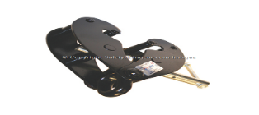
DESCRIPTION | WIDTH | SWL | PRICE
Adjustable Beam Clamp | 70 – 245mm | 1t | £26.18
Adjustable Beam Clamp | 70 – 245mm | 2t | £29.29
Adjustable Beam Clamp | 70 – 355mm | 3t | £49.78
Adjustable Beam Clamp | 70 – 355mm | 5t | £58.88
Adjustable Beam Clamp | 80 – 350mm | 10t | £91.59
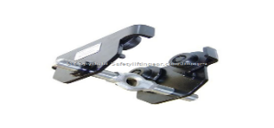
BEAM CLAMPS

DESCRIPTION | WIDTH | SWL | PRICE
Adjustable Beam Trolley | 50 – 220mm | 500kg | £42.12
Adjustable Beam Trolley | 50 - 220mm | 1t | £54.60
Adjustable Beam Trolley | 60 - 220mm | 2t | £79.63
Adjustable Beam Trolley | 90 – 220mm | 5t | £204.47
Adjustable Beam Trolley | 160 – 305mm | 500kg | £58.10
Adjustable Beam Trolley | 160 - 305mm | 1t | £74.04
Adjustable Beam Trolley | 160 - 305mm | 2t | £103.02
Adjustable Beam Trolley | 160 – 305mm | 5t | £240.50
All price excludes VAT & Carriage
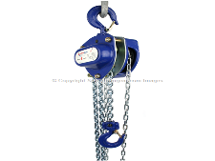
CHAIN BLOCKS

DESCRIPTION | EWL | SWL | PRICE
Chain Block Hoist Heavy Duty Industrial Quality | 3mtr | 500Kgs | £50.63
Chain Block Hoist Heavy Duty Industrial Quality | 4mtr | 500Kgs | £55.61
Chain Block Hoist Heavy Duty Industrial Quality | 6mtr | 500Kgs | £68.06
Chain Block Hoist Heavy Duty Industrial Quality | 3mtr | 1 tonne | £57.27
Chain Block Hoist Heavy Duty Industrial Quality | 4mtr | 1 tonne | £62.25
Chain Block Hoist Heavy Duty Industrial Quality | 6mtr | 1 tonne | £74.45
Chain Block Hoist Heavy Duty Industrial Quality | 3mtr | 2 tonne | £79.88
Chain Block Hoist Heavy Duty Industrial Quality | 4mtr | 2 tonne | £86.19
Chain Block Hoist Heavy Duty Industrial Quality | 6mtr | 2 tonne | £99.55
Chain Block Hoist Heavy Duty Industrial Quality | 3mtr | 3 tonne | £121.05
Chain Block Hoist Heavy Duty Industrial Quality | 4mtr | 3 tonne | £132.75
Chain Block Hoist Heavy Duty Industrial Quality | 6mtr | 3 tonne | £164.54
Chain Block Hoist Heavy Duty Industrial Quality | 3mtr | 5 tonne | £193.59
Chain Block Hoist Heavy Duty Industrial Quality | 4mtr | 5 tonne | £211.48
Chain Block Hoist Heavy Duty Industrial Quality | 6mtr | 5 tonne | £246.53

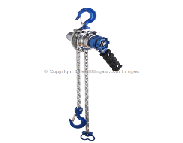
LEVER HOIST

DESCRIPTION | EWL | SWL | PRICE
Very Light Professional Lever Hoist | 1.5mtr | 500Kgs | £57.21
Very Light Professional Lever Hoist | 1.5mtr | 750Kgs | £66.38
Very Light Professional Lever Hoist | 3mtr | 750Kgs | £107.00
Very Light Professional Lever Hoist | 1.5mtr | 1 tonne | £66.40
Very Light Professional Lever Hoist | 3mtr | 1 tonne | £67.79
Very Light Professional Lever Hoist | 1.5mtr | 1.5 tonne | £73.28
Very Light Professional Lever Hoist | 3mtr | 1.5 tonne | £89.16
Very Light Professional Lever Hoist | 1.5mtr | 2 tonne | £93.58
Very Light Professional Lever Hoist | 3mtr | 2 tonne | £112.05
Very Light Professional Lever Hoist | 1.5mtr | 3 tonne | £126.99
Very Light Professional Lever Hoist | 3mtr | 3 tonne | £152.00

All price excludes VAT & Carriage

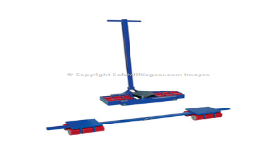
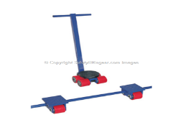
MACHINE MOVING SKATES

DESCRIPTION |  |  |  |  | SWL | Price
Machine moving skates set consists of 1 x 4t steering skate with turntable  2 x 2t trailing skates |  |  |  |  | 8t | £206.46
Machine moving skates set consists of 1 x 8t steering skate with turntable  2 x 4t trailing skates |  |  |  |  | 16t | £398.41
Machine moving skates set consists of 1 x 12t steering skate with turntable  2 x 6t trailing skates |  |  |  |  | 24t | £574.36
Machine moving skates set consists of 1 x 16t steering skate with turntable  2 x 8t trailing skates |  |  |  |  | 32t | £915.53
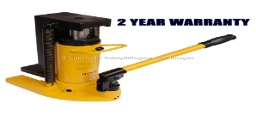
HYDRAULIC JACKS

DESCRIPTION | CAPACITY ON JACK | CAPACITY ON TOE | HEGHT OF  TOE | TOTAL CLOSED HEIGHT | STROKE | PRICE
Hydraulic Toe Jack | 5t | 2.5t | 19mm | 243mm | 120mm | £195.83
Hydraulic Toe Jack | 10t | 5t | 22mm | 290mm | 150mm | £214.97
Hydraulic Toe Jack | 20t | 10t | 28mm | 327mm | 160mm | £323.70
Hydraulic Toe Jack | 30t | 15t | 32mm | 347mm | 160mm | £322.87

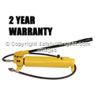
HYDRAULIC PUMPS & CYLINDERS

DESCRIPTION | MAX PRESSURE | PRICE
Hydraulic Two Speed Pump 1.8mtr hose with Male Coupling | 10,000 PSI | £166.02
Light Weight Two Speed Aluminium Hand Pump 1.8mtr Hose with Male Coupling | 10,000 PSI | £217.33
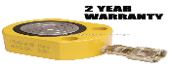
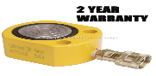
PAD JACKS
DESCRIPTION | Closed Height | Width |  | Length Including Coupling | Stroke |  | SWL |  | PRICE
Pad Jack Cylinder | 48mm | 60mm |  | 145mm | 11mm |  | 10t |  | £103.53
Pad Jack Cylinder | 56mm | 70mm |  | 165mm | 12mm |  | 20t |  | £126.44
Pad Jack Cylinder | 62mm | 97mm |  | 180mm | 14mm |  | 30t |  | £139.33
Pad Jack Cylinder | 72mm | 97mm |  | 180mm | 16mm |  | 50t |  | £203.05
Pad Jack Cylinder | 92mm | 160mm |  | 135mm | 16mm |  | 100t |  | £278.77

All price excludes VAT & Carriage

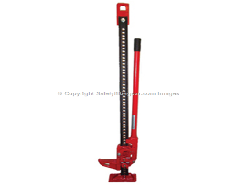

BAR JACKS
DESCRIPTION | SWL | PRICE
High Lift Mechanical Bar Jacks 48 | 3.5t at first 12” after this height the lifting capacity reduces | £43.50
High Lift Mechanical Bar Jacks 60 | 3.5t at first 12” after this height the lifting capacity reduces | £45.79
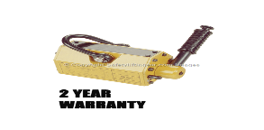
LIFTING MAGNETS
DESCRIPTION | SWL | PRICE
Lifting Magnet | 100Kg | £183.58
Lifting Magnet | 300Kgs | £168.34
Lifting Magnet | 600Kgs | £399.00
Lifting Magnet | 1000Kgs | £572.67
Lifting Magnet | 2000Kgs | £1,144.13
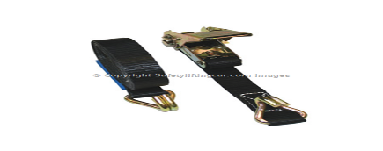
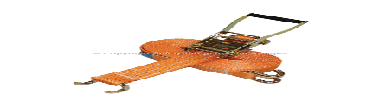
RATCHET STRAPS
DESCRIPTION | WIDTH | LENGTH | SWL | PRICE
Ratchet lashing, c/w Chassis Hooks | 25mm | 4mtr | 500Kgs | £3.41
Ratchet lashing, c/w Chassis Hooks | 25mm | 6mtr | 500Kgs | £4.10
Ratchet lashing, c/w Chassis Hooks | 25mm | 4mtr | 1000Kgs | £4.52
Ratchet lashing, c/w Chassis Hooks | 25mm | 6mtr | 1000Kgs | £4.98
Ratchet lashing, c/w Claw Hooks | 50mm | 4mtr | 2000Kgs | £5.70
Ratchet lashing, c/w Claw Hooks | 50mm | 6mtr | 2000Kgs | £6.28
Ratchet lashing, c/w Claw Hooks | 50mm | 4mtr | 3000Kgs | £5.96
Ratchet lashing, c/w Claw Hooks | 50mm | 6mtr | 3000Kgs | £6.51
Ratchet lashing, c/w Claw Hooks | 50mm | 6mtr | 4000Kgs | £6.34
Ratchet lashing, c/w Claw Hooks | 50mm | 8mtr | 4000Kgs | £7.20
Ratchet lashing, c/w Claw Hooks | 50mm | 10mtr | 4000Kgs | £7.61
Ratchet lashing, c/w Claw Hooks | 50mm | 4mtr | 5000Kgs | £4.67
Ratchet lashing, c/w Claw Hooks | 50mm | 6mtr | 5000Kgs | £6.63
Ratchet lashing, c/w Claw Hooks | 50mm | 8mtr | 5000Kgs | £7.42
Ratchet lashing, c/w Claw Hooks | 50mm | 10mtr | 5000Kgs | £7.67
Ratchet lashing, c/w Claw Hooks | 50mm | 12mtr | 5000Kgs | £9.71
Ratchet lashing, c/w Claw Hooks | 50mm | 15mtr | 5000Kgs | £11.27
Ratchet lashing, c/w Claw Hooks | 50mm | 20mtr | 5000Kgs | £14.64
Ratchet lashing, c/w Claw Hooks | 75mm | 6mtr | 10,000Kgs | £20.40
Ratchet lashing, c/w Claw Hooks | 75mm | 8mtr | 10,000Kgs | £22.55
Ratchet lashing, c/w Claw Hooks | 75mm | 10mtr | 10,000Kgs | £26.14
Ratchet lashing, c/w Claw Hooks | 75mm | 12mtr | 10,000Kgs | £28.63
Ratchet lashing, c/w Claw Hooks | 75mm | 15mtr | 10,000Kgs | £31.26

All price excludes VAT & Carriage
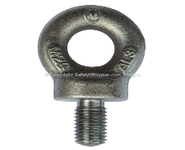
COLLARED EYE BOLTS
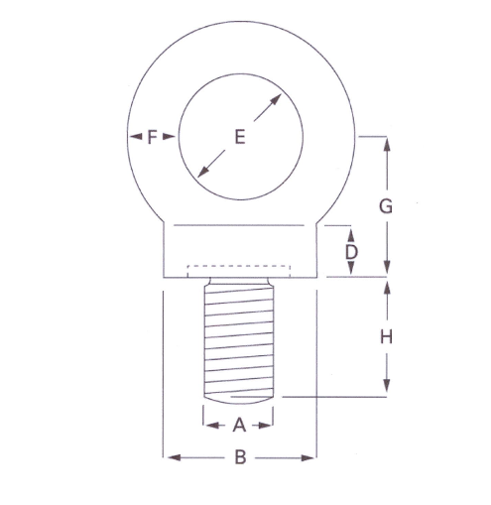
Available to BS4278 Table 1 -1984 (Tested & Certified)
 | Vertical SWL Tonnes | A  mm | B  mm | D  mm | E  mm | F  mm | G  mm | H  mm | WEIGHT EACH  Kgs | PRICE
* | 0.10 | 6 | 22 | 7 | 15 | 9 | 20 | 18 | 0.06 | £1.20
* | 0.15 | 8 | 22 | 7 | 15 | 9 | 20 | 18 | 0.06 | £1.37
* | 0.25 | 10 | 22 | 7 | 15 | 9 | 20 | 18 | 0.06 | £1.45
 | 0.40 | 12 | 22 | 7 | 15 | 9 | 20 | 18 | 0.06 | £1.64
* | 0.50 | 14 | 29 | 10 | 20 | 12 | 26 | 23 | 0.15 | £4.30
 | 0.80 | 16 | 29 | 10 | 20 | 12 | 26 | 23 | 0.15 | £1.90
 | 1.60 | 20 | 40 | 14 | 27 | 16 | 36 | 32 | 0.38 | £2.89
 | 2.50 | 24 | 52 | 17 | 35 | 21 | 46 | 40 | 0.85 | £5.22
 | 4.00 | 30 | 65 | 22 | 44 | 26 | 58 | 51 | 1.62 | £10.28
 | 6.30 | 36 | 81 | 27 | 54 | 32 | 72 | 63 | 3.12 | £18.55
Sizes marked * are additional & proportional to the specifications

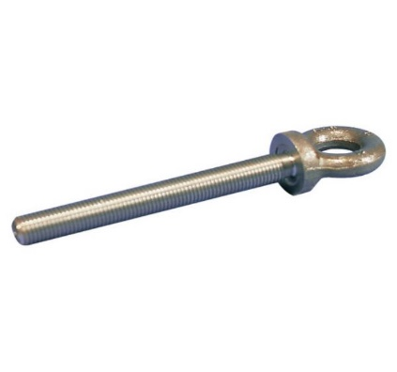

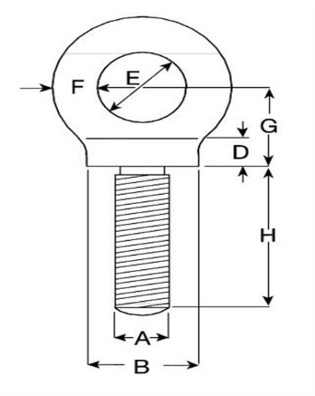
LONG SHANK COLLARED EYEBOLTS METRIC THREAD
Vertical SWL Tonnes | A  mm | B  mm | D  mm | E  mm | F  mm | G  mm | H  mm | WEIGHT EACH  Kgs | PRICE
0.25 | 10 | 22 | 7 | 15 | 9 | 20 | 178 | 0.18 | £7.66
0.40 | 12 | 28 | 10 | 19 | 11 | 25 | 178 | 0.25 | £8.64
0.80 | 16 | 36 | 12 | 24 | 14 | 32 | 178 | 0.44 | £10.18
1.60 | 20 | 43 | 14 | 28 | 17 | 38 | 178 | 0.70 | £11.91
2.50 | 24 | 57 | 19 | 38 | 22 | 51 | 178 | 1.50 | £15.97
4.00 | 30 | 71 | 24 | 48 | 28 | 64 | 178 | 2.80 | £27.31

All price excludes VAT & Carriage
Chartered Institute of Environmental Health Professional Trainers
Registered office: The Lymes off old York Road, Hillcrest, Skellow, Doncaster, South Yorkshire DN6 8LN
Reg. No 3953535 E-mail: sales@cablesafe.co.uk www.cablesafe.co.uk
Tel: 01302 726264 Fax: 01302 722438

